SECURE DATA TRANSMISSION IN CLOUD COMPUTING USING ENCRYPTION AND MACHINE LEARNING
Conclusion, Future Scope and References
Department of Computer Science and Engineering, TKR College of Engineering & Technology
Batch A5 (CSE-A) · Academic year [ACADEMIC YEAR]
Table 1: Project team
S.No. | Student name | Roll number
1 | Avuti Sandhya | 23K91A0520
2 | Banothu Indu | 23K91A0530
3 | Dasari Sriteja | 23K91A0559
4 | Bejugam Vaishnavi | 23K91A0533

Project guide: CH. Prabhakar
Chapter and section numbers quoted in the text (for example Chapter 8 or Section 6.2) refer to the full project report, 17.Final Document. Figures and tables in this document are numbered from 1.

1. CONCLUSION

1.1 Summary of the work
This project built CipherGuard Shield, a platform that puts two protections around one cloud data path: SecureChannel, which encrypts a payload with a fresh ECDH P-256 key, HKDF-SHA256 and AES-256-GCM and verifies it at the cloud, and the ThreatSense Engine, which classifies network flows with XGBoost, a 1D CNN and logistic-regression stacking and logs attacks with a severity. A REST API, a React console and the original dashboard expose both. The work was then measured: on real UNSW-NB15 flows, in cryptographic benchmarks and in a combined pipeline test, and verified with 26 automated tests and 15 smoke checks.

1.2 Objectives achieved
Table 2: The six objectives of the batch against the outcome
# | Objective | Outcome
1 | Hybrid AES + RSA scheme | Partly met by substitution: ECDH + HKDF + AES-256-GCM; RSA hybrids benchmarked only
2 | Key generation, distribution, storage | Generation and distribution met; storage not met (in-memory mock cloud key)
3 | Encrypt before upload, decrypt after download | Met against a mock cloud, text and files, with tamper rejection
4 | Classifier on a benchmark dataset | Met in experiments on real UNSW-NB15 (0.890 ± 0.002 stacked, 0.910 ± 0.001 XGBoost); default model synthetic
5 | Flag and log suspicious sessions | Partly met: flows scored and logged in memory; not tied to a transfer; nothing blocked
6 | Evaluate times, overhead and accuracy | Met: sub-millisecond crypto up to 100 KB, 5.7 ms combined transfer, detection metrics with seeds

1.3 Key findings
1. Authenticated encryption is cheap and behaved exactly as specified. 1,000 of 1,000 trials of each of six tamper cases were correct; a protected 100 KB transfer costs 5.7 ms, of which 81% is detection.
2. The synthetic default says nothing about real traffic. 0.9733 on synthetic data against 0.660 (ROC-AUC 0.657) on the 82,332 real test flows.
3. On real data the detector ranks well but alarms too often. Stacked accuracy 0.890 ± 0.002, ROC-AUC 0.984 ± 0.000, false-positive rate 0.222 ± 0.004; a threshold of 0.9 gives accuracy 0.921 and a false-positive rate of 0.096.
4. Stacking gave no gain over XGBoost. XGBoost alone: 0.910 ± 0.001 on the official partition and 0.939 ± 0.007 against 0.938 ± 0.007 under the base paper's protocol.
5. Against the base paper the stacked model is about one point lower under a comparable protocol (0.938 ± 0.007 against 0.9487); the comparison is indicative only because the datasets differ in their subsets.

1.4 Practical applications
• A teaching and prototyping platform for encrypting data before upload and watching network flows in one place.
• A reference implementation of ephemeral-key hybrid encryption with tamper tests and a measured RSA baseline.
• A starting point for a flow-based alerting service once live flow export, authentication and persistent storage are added (Chapter 10).
• A template for reporting an intrusion-detection result honestly: real data, official split, seeds, thresholds, categories and a synthetic-versus-real audit.

1.5 Known limitations
The default model is synthetic; the official test set is harder than a random split and produces 22.6% false alarms on normal traffic at threshold 0.5; Fuzzers are missed 13.3% of the time; the cloud is a mock with in-memory keys; there is no authentication, TLS or persistent store; live traffic and adversarial inputs were not tested; and the base paper's EECC and quantum-inspired network were not reproduced. Chapter 8 and the Scope and Limitations document give the full list.

1.6 Lessons learned
• Report the data a number was measured on in the same sentence as the number; a synthetic 97% and a real 89% are different claims.
• Run the simple baseline first. XGBoost alone matched or beat a three-model stack, a result that would have stayed hidden without a baseline table.
• Prefer standard, maintained primitives and measure them against the alternative that was asked for (RSA) rather than adopting a non-standard scheme.
• Make the evaluation protocol part of the result: the same stacked design scored 0.938 ± 0.007 on a random balanced subset and 0.890 ± 0.002 on the temporally split official partition.
• Keep experiments scripted and their output stored as JSON, so every number in the documents can be traced and regenerated.
The results behind the key findings are shown below: how the stacked ensemble compares with its parts on real data, and how the measured accuracy sits next to the figures reported in the base paper.
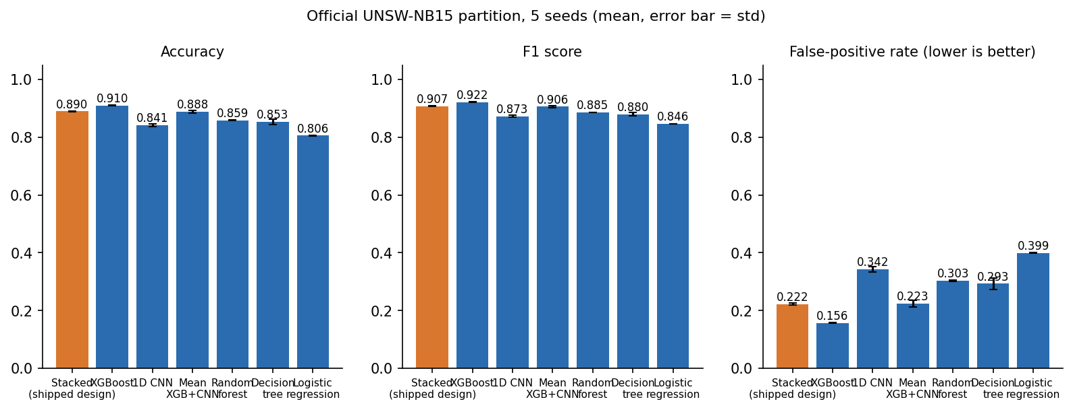
Figure 1: Accuracy, F1 and false-positive rate of the stacked ensemble, its two parts and three baselines on the official UNSW-NB15 partition (5 seeds).
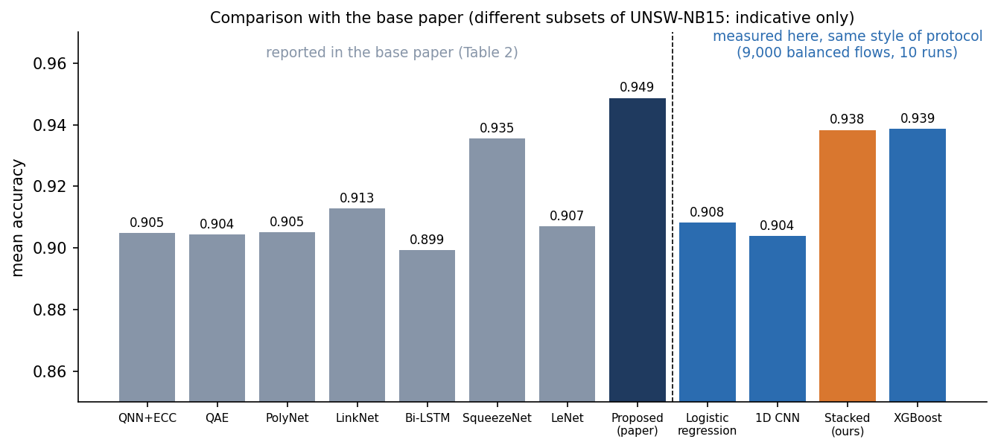
Figure 2: Mean accuracy reported in the base paper next to the values measured here under a comparable protocol (indicative only: different subsets).

2. FUTURE SCOPE

2.1 Improvements to the existing system
• Make the real-trained bundle the default and ship the data-fetch script, so the console shows real-data metrics from the first start; keep the synthetic generator only as a test fixture.
• Choose the decision threshold on a validation set and expose it in the console; a threshold of 0.9 already cuts the false-positive rate on the official partition from 0.226 to 0.096.
• Train the CNN with class weights (the TensorFlow branch already does) and compare with XGBoost alone; drop the CNN if it still adds nothing.
• Fit the stacking meta-model on data from a period later than the training data, or replace it by simple averaging with a calibrated XGBoost.
• Replace the session-key cache by a strict ECDH-only decrypt path and remove the demo shortcut.

2.2 Additional features
• Flow export instead of CSV rows: read flows from a tap or a flow exporter (for example Zeek or NetFlow) and score them continuously.
• Gate transfers on verdicts: hold, quarantine or require approval for a transfer whose session is flagged, and tie alerts to sessions.
• Persistent alert store (a database), search, acknowledgement and export.
• Authentication, authorisation and TLS for the API and the console, with audit logging.
• Key management: a KMS or HSM for the cloud key, key rotation and certificates for the cloud's public key.
• Multi-class detection (attack category, not only attack or normal) and explanations of verdicts.

2.3 Scalability and deployment
• Containerise and test the existing Docker files, run the API behind a reverse proxy and several workers; scoring 1,000 rows takes about 17 ms in process, so one core can serve thousands of flows a second, while the CNN's 4-minute training and XGBoost's 4 seconds make regular retraining jobs practical.
• Move the cloud endpoint into a separate service with its own key custody and a real object store, then measure real network latency and concurrency.
• Add drift monitoring: track the distribution of the 42 features and the alert rate, and retrain when they move.

2.4 Further research
• Evaluate on more recent and more varied data sets and on traffic captured in a real network; test whether the sttl dependence disappears.
• Test adversarial robustness: evasive flows, poisoned training data, and the effect of attackers who know the model.
• Reproduce the base paper's EECC and quantum-inspired network, and compare them with the standard primitives and models used here on the same data.
• Study federated or privacy-preserving training so that several clouds can share a detector without sharing flows.
• Provide a significance analysis and confidence intervals for the comparison between stacked and single models.

2.5 Suggested order of work
Table 3: Future work ranked by value and effort
Priority | Item | Effort | Why first
1 | Real-trained model as default, threshold chosen on validation data | Small | Removes the synthetic-data trap and halves the false-alarm rate
2 | Authentication, TLS, ECDH-only decrypt path | Small to medium | Closes the demo shortcuts that block any real use
3 | Persistent alert store and session-linked verdicts | Medium | Makes alerts durable and attributable to a transfer
4 | Flow export and continuous scoring | Medium to large | Moves from supplied records to live traffic
5 | KMS or HSM key custody, rotation, certificates | Medium | Meets the key-storage objective that is not met today
6 | Adversarial testing, drift monitoring, other data sets | Large | Shows whether the results survive outside UNSW-NB15

3. REFERENCES
[1] V. Kalyanasundaram, S. Raja and S. Kanthimathi, "Intrusion detection model using fused quantum NN-LeNet with improved elliptic curve cryptography based data security," IEEE Access, vol. 14, pp. 63767-63779, 2026, doi: 10.1109/ACCESS.2026.3686106.
[2] H. Boye, "Strengthening cloud security through advanced encryption and anomaly detection techniques for secure data storage and transmission," FMDB Trans. Sustain. Comput. Lett., vol. 2, no. 3, pp. 153-163, 2024, doi: 10.69888/FTSCL.2024.000241.
[3] J. Singh and G. S. Bhathal, "An automated data deletion: a secure method for multi-cloud security with intrusion detection system," Int. J. Sci. Res. (IJSR), vol. 13, no. 8, pp. 213-217, Aug. 2024, doi: 10.21275/SR24730194843.
[4] M. B. Shinde and P. P. Ghadekar, "Federated learning-based attack detection and secure data transmission in cloud using improved Blowfish encryption," Eng. Appl. Artif. Intell., vol. 182, Art. no. 115975, 2026, doi: 10.1016/j.engappai.2026.115975.
[5] N. Pamarthi and N. Rao N, "A cloud-based data privacy framework using hybrid encryption algorithms for secure data transmission," Genet. Mol. Res., 2026, doi: 10.4238/mq5a9v31.
[6] M. M. Alhusseini, A. Rouhi and M.-R. Feizi-Derakhshi, "AI-powered hybrid intrusion detection framework for cloud security using novel metaheuristic optimization," arXiv:2601.01134, Jan. 2026.
[7] N. Moustafa and J. Slay, "UNSW-NB15: a comprehensive data set for network intrusion detection systems (UNSW-NB15 network data set)," in Proc. Mil. Commun. Inf. Syst. Conf. (MilCIS), Canberra, Australia, 2015, pp. 1-6, doi: 10.1109/MilCIS.2015.7348942.
[8] N. Moustafa and J. Slay, "The evaluation of network anomaly detection systems: statistical analysis of the UNSW-NB15 data set and the comparison with the KDD99 data set," Inf. Secur. J.: Global Perspective, vol. 25, no. 1-3, pp. 18-31, 2016, doi: 10.1080/19393555.2015.1125974.
[9] T. Chen and C. Guestrin, "XGBoost: a scalable tree boosting system," in Proc. 22nd ACM SIGKDD Int. Conf. Knowl. Discovery Data Mining, San Francisco, CA, USA, 2016, pp. 785-794, doi: 10.1145/2939672.2939785.
[10] Y. LeCun, L. Bottou, Y. Bengio and P. Haffner, "Gradient-based learning applied to document recognition," Proc. IEEE, vol. 86, no. 11, pp. 2278-2324, Nov. 1998, doi: 10.1109/5.726791.
[11] D. H. Wolpert, "Stacked generalization," Neural Netw., vol. 5, no. 2, pp. 241-259, 1992, doi: 10.1016/S0893-6080(05)80023-1.
[12] M. Dworkin, "Recommendation for block cipher modes of operation: Galois/Counter Mode (GCM) and GMAC," NIST Special Publication 800-38D, Nov. 2007, doi: 10.6028/NIST.SP.800-38D.
[13] E. Barker, L. Chen, A. Roginsky, A. Vassilev and R. Davis, "Recommendation for pair-wise key-establishment schemes using discrete logarithm cryptography," NIST Special Publication 800-56A, Rev. 3, Apr. 2018, doi: 10.6028/NIST.SP.800-56Ar3.
[14] H. Krawczyk and P. Eronen, "HMAC-based extract-and-expand key derivation function (HKDF)," IETF RFC 5869, May 2010, doi: 10.17487/RFC5869.
[15] National Institute of Standards and Technology, "Advanced Encryption Standard (AES)," Federal Information Processing Standards Publication 197, Nov. 2001 (updated May 2023), doi: 10.6028/NIST.FIPS.197-upd1.
[16] K. Moriarty, B. Kaliski, J. Jonsson and A. Rusch, "PKCS #1: RSA cryptography specifications version 2.2," IETF RFC 8017, Nov. 2016, doi: 10.17487/RFC8017.
[17] F. Pedregosa et al., "Scikit-learn: machine learning in Python," J. Mach. Learn. Res., vol. 12, pp. 2825-2830, 2011.
[18] A. Paszke et al., "PyTorch: an imperative style, high-performance deep learning library," in Adv. Neural Inf. Process. Syst. (NeurIPS), vol. 32, 2019, arXiv:1912.01703.
[19] D. P. Kingma and J. Ba, "Adam: a method for stochastic optimization," in Proc. 3rd Int. Conf. Learn. Represent. (ICLR), 2015, arXiv:1412.6980.
[20] H. Kadry, A. Farouk, E. A. Zanaty and O. Reyad, "Intrusion detection model using optimized quantum neural network and elliptical curve cryptography for data security," Alexandria Eng. J., vol. 71, pp. 491-500, May 2023, doi: 10.1016/j.aej.2023.03.072.
[21] M. Nadeem, A. Arshad, S. Riaz, S. S. Band and A. Mosavi, "Intercept the cloud network from brute force and DDoS attacks via intrusion detection and prevention system," IEEE Access, vol. 9, pp. 152300-152309, 2021, doi: 10.1109/ACCESS.2021.3126535.
[22] M. Bakro, R. R. Kumar, A. A. Alabrah, Z. Ashraf, M. N. Ahmed, M. Shameem and A. Abdelsalam, "An improved design for a cloud intrusion detection system using hybrid features selection approach with ML classifier," IEEE Access, vol. 11, pp. 64228-64247, 2023, doi: 10.1109/ACCESS.2023.3289405.
[23] E. B. Mbaya, E. Adetiba, J. A. Badejo, J. S. Wejin, O. Oshin and O. Isife, "SecFedIDM-V1: a secure federated intrusion detection model with blockchain and deep bidirectional long short-term memory," IEEE Access, vol. 11, pp. 116011-116025, 2023, doi: 10.1109/ACCESS.2023.3325992.
[24] S. Rahman, S. Pal, S. Mittal, T. Chawla and C. Karmakar, "SYN-GAN: a robust intrusion detection system using GAN-based synthetic data for IoT security," Internet Things, vol. 26, Art. no. 101212, Jul. 2024, doi: 10.1016/j.iot.2024.101212.
[25] F. Alrayes, M. Zakariah, S. Amin, Z. Khan and J. Alqurni, "Network security enhanced with deep neural network-based intrusion detection system," Comput. Mater. Continua, vol. 80, no. 1, pp. 1457-1490, 2024, doi: 10.32604/cmc.2024.051996.
[26] S. Lin, C. Feng, T. Jiang and H. Jing, "Evaluation of network security grade protection combined with deep learning for intrusion detection," IEEE Access, vol. 11, pp. 130990-131000, 2023, doi: 10.1109/ACCESS.2023.3333013.
[27] M. M. Alani, A. I. Awad and E. Barka, "A hybrid ensemble learning-based intrusion detection system for the Internet of Things," in Proc. IEEE Int. Conf. Cyber Secur. Resilience (CSR), 2024, pp. 1-8, doi: 10.1109/CSR61664.2024.10679427.
[28] E.-U.-H. Qazi, T. Zia, M. H. Faheem, K. Shahzad, M. Imran and Z. Ahmed, "Zero-touch network security (ZTNS): a network intrusion detection system based on deep learning," IEEE Access, vol. 12, pp. 141625-141638, 2024, doi: 10.1109/ACCESS.2024.3466470.
[29] M. Hdaib, S. Rajasegarar and L. Pan, "Quantum deep learning-based anomaly detection for enhanced network security," Quantum Mach. Intell., vol. 6, no. 1, Art. no. 26, 2024, doi: 10.1007/s42484-024-00163-2.
[30] D. Vengala, D. Kavitha and A. P. S. Kumar, "Three factor authentication system with modified ECC based secured data transfer: untrusted cloud environment," Complex Intell. Syst., vol. 9, no. 3, pp. 2915-2928, 2023, doi: 10.1007/s40747-021-00305-0.
[31] S. M. Kasongo and Y. Sun, "Performance analysis of intrusion detection systems using a feature selection method on the UNSW-NB15 dataset," J. Big Data, vol. 7, Art. no. 105, 2020, doi: 10.1186/s40537-020-00379-6.
[32] R. Vinayakumar et al., "Deep learning approach for intelligent intrusion detection system," IEEE Access, vol. 7, pp. 41525-41550, 2019, doi: 10.1109/ACCESS.2019.2895334.
[33] Z. Ahmad et al., "Network intrusion detection system: a systematic study of machine learning and deep learning approaches," Trans. Emerg. Telecommun. Technol., vol. 32, no. 1, Art. no. e4150, 2021, doi: 10.1002/ett.4150.
[34] M. Ring et al., "A survey of network-based intrusion detection data sets," Comput. Secur., vol. 86, pp. 147-167, Sep. 2019, doi: 10.1016/j.cose.2019.06.005.
[35] Z. Zoghi and G. Serpen, "UNSW-NB15 computer security dataset: analysis through visualization," arXiv:2101.05067, 2021.
[36] P. Goldschmidt and D. Chuda, "Network intrusion datasets: a survey, limitations, and recommendations," arXiv:2502.06688, 2025.
[37] V. Mahalle and A. Shahade, "Enhancing the data security in cloud by implementing hybrid (RSA & AES) encryption algorithm," in Proc. Int. Conf. Power, Autom. Commun. (INPAC), 2014, pp. 146-149, doi: 10.1109/INPAC.2014.6981152.
[38] B. Ranganatha Rao and B. Sujatha, "A hybrid elliptic curve cryptography (HECC) technique for fast encryption of data for public cloud security," Meas.: Sens., vol. 29, Art. no. 100870, Oct. 2023, doi: 10.1016/j.measen.2023.100870.
[39] L. Sudha and C. Arunachalaperumal, "Optimized hybrid advanced encryption standard and elliptic curve cryptography-based secure data storage in cloud environment," Iran. J. Sci. Technol., Trans. Electr. Eng., vol. 49, no. 3, pp. 1045-1070, 2025, doi: 10.1007/s40998-025-00816-3.
[40] "Securing data transmission and storage in cloud computing using hybrid AES-256 and RSA encryption and key management technique," Int. J. Sci. Eng. Appl., Mar. 2025, doi: 10.7753/IJSEA1403.1013 (authors not listed in the Crossref or OpenAlex records).

